Help fill the truck for Lutheran World Relief

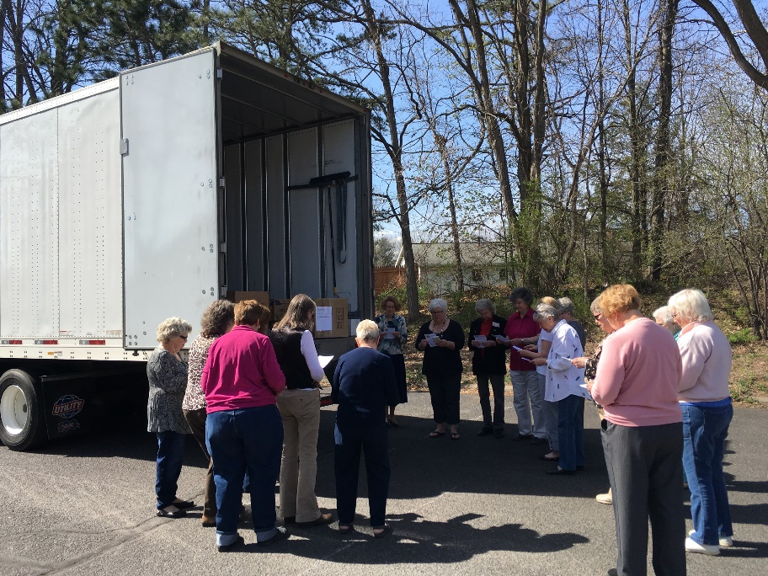
Once again, LWR is providing a semi-truck at three Upstate NY locations to accept donations of:
Quilts,
School Kits,
Personal Care Kits,
Baby Kits,
Fabric Kits,
Fleece Tied Blankets,
Soap (new larger bars)
Ingathering Locations & Dates:
Hilton, NY: May 7 – 10, 2019
Syracuse, NY: May 5 - 11, 2019
Clifton Park, NY: May 8, 9, & 11 2019
More details of the drop off location of your choice on 2nd page of this flyer.
How to pack your donations:
Pack – each type of Kit, Quilts, Fleece Blankets, & Soap in a separate box not exceeding 40 lb.
For example, if you are donating Personal Care Kits, School Kits, & Fleece Tied Blankets, then you would have at least three boxes, one each for the Health Kits, School Kits, & Fleece Tied Blankets. No plastic bags inside boxes, just the donated items.
Label each box as to contents including number & type of Kits, Quilts, Fleece Blankets or Soap as well as your church name and address on box or use the LWR Kit & Quilt Tracker bar codes – see next paragraph for info.
To find out where your donations ended up check out how to use the LWR Kit & Quilt Tracker at: lwr.org/tracker?current=/node/290

In a World of Crisis, Do a World of Good
Earthquakes. Hurricanes. W

Upstate NY LWR Ingathering Details

Hilton, NY – St. Paul Lutheran Church & School
158 East Ave.
Hilton, NY 14468

Contact: Carolyn Hurlbutt, 585-392-3794, carolynhurlbutt@gmail.com

Church Office: 585-392-3120

Date & Times to Drop Off: Please call for exact times.

Syracuse NY – Atonement Lutheran Church
116 West Glen Avenue
Syracuse, NY 13205

Contact: Laura Light, 315-423-3434, laura.light@alcsyracuse.org

Church Office: 315-492-9065

Date & Times to Drop Off: Sunday, May 5: 9:00 a.m. – Noon
Monday, May 6, through Friday, May 10, 2019: 10:00 am – 1:00pm

Drop Off & Load Truck: Saturday, May 11 2019: 9:00 a.m. – 10:30 a.m.

Please Note: Please drop off donations during any of the above listed dates & times. Call for special circumstances.

Clifton Park, NY – Prince of Peace Lutheran Church
4 Northcrest Drive (exit 9w from I-87)
Clifton Park, NY 12065

Contact: Sarah Fisher, 518-306-4667, fishersarah@me.com

Church Office: 518-371-2226

Date & Times to Drop Off: Wednesday, May 8, 2019: 6:30 p.m. - 8:00 p.m.
Thursday, May 9, 2019: 1:30 p.m. – 3:30 p.m.
Drop Off & Load Truck: Saturday, May 11, 2019: 2:00 p.m. – 3:30 p.m.

