WORKSHOPS
Old Ideas in a New Time: Faith
and Spiritual Formation for Today
Rev. Lori Kochanski, Asst to Bishop for
Faith Formation
Consider all the old stories told in new ways. Explore different styles of teaching and learning through deeper listening to God, Jesus and the Holy Spirit. Idea sharing and the practice of new concepts.

Helping Your Folks Tell their
Faith Story
Rev. Norma Malfatti, DEM
Even the strongest of believers need help talking about their faith, whether with unchurched or the person next to them in the pew. Explore ways to help people frame their faith story, practice telling it and, most importantly, send you home with tools to use in their own congregation.

Poor People’s Campaign: A National Call for Moral Revival
Rev. Dana Smith, Senior Pastor of Atonement Ministries, Syracuse
Rev. Beth DuBois, Developer Appleseed Community @ Atonement, Syracuse
The PPC joins people directly impacted by systemic racism, poverty, ecological devastation & the nation's distorted morality with their allies. Atonement advocates and serves a population intimately familiar with poverty. Learn more about the scope of PPC work around NY along with future actions.

September 17-19, 2018
Synod Ministerium Retreat Registration

Full Retreat Registration Fee: $245 One-Day/One-Night & Commuter Registration Fee: $145

Register online at the Upstate New York Synod website: http://upstatenysynod.org
Questions?
The Rev. Gail Wolling
gwolling@gmail.com
518-225-7537
Notre Dame Retreat House 5151 Foster Road Canandaigua NY
585-394-5700
http://notredameretreat.org
Directions available online

Grounded
Growing
Giving
Graced
UPSTATE NEW YORK SYNOD ANNUAL
MINISTERIUM RETREAT
SEPTEMBER 17-19, 2018
Notre Dame Retreat House Canandaigua, New York
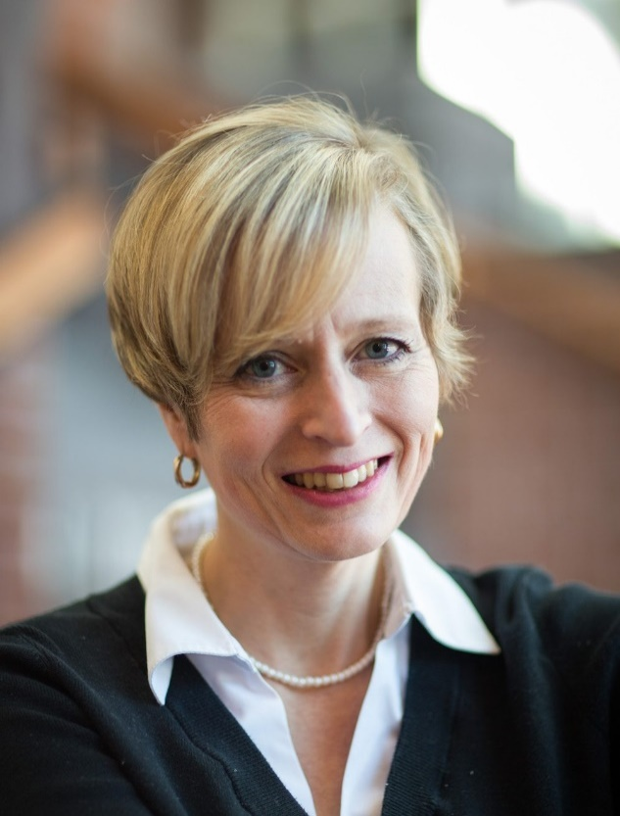

Preaching Across the Divide: Wrestling with Difficult Topics

The Rev. Dr. Angela Zimmann

Professor of Homiletics

United Lutheran Seminary Gettysburg, PA

Preaching Across the Divide
Worship

Pastor Emily Ebert leads our Worship Team this year, calling on the creativity of our Western NY colleagues.
Schedule

MONDAY
1:00pm Arrival
2:30pm Opening Prayer
3:15pm Welcome & Announcement
3:45-5:15pm Plenary I – Dr. Angela Zimmann
6:00-7:00pm Dinner
7:00-8:15pm Plenary II – Dr. Angela Zimmann
8:30pm Evening Prayer
9:00pm Fellowship
TUESDAY
8:00-9:00am Breakfast
9:00am Morning Prayer
9:15-10:30am Plenary III - Dr. Angela Zimmann
11:00-Noon Workshops
Noon-1:00pm Lunch
1:00-6:00pm Free Time
6:00-7:00pm Dinner
7:00-8:15pm Town Meeting: Bishop Macholz
8:30pm Evening Prayer
9:00pm Fellowship
WEDNESDAY
8:00-9:00a Breakfast
9:00-10:30a Plenary IV – Dr. Angela Zimmann
10:30am Evaluation
10:45am Eucharist Worship
Noon-1:00pm Lunch
Schedule Subject to Change

The Rev Dr. Angela Zimmann, Adjunct Professor of Homiletics and Vice President for Advancement at United Lutheran Seminary, Gettysburg will make use of personal and classroom experiences to lead us in the process of developing a homiletical approach to topics folks find confusing or divisive. Participants will hear her approaches and then work together in smaller groups to begin the process on their own. Our time together should offer an opportunity for rich textual conversation along with practical experience putting together a sermon on a topic relevant in our congregation.

Pastor Zimmann began this work in her first congregation when she preached a series on the topics that most concerned her conservative congregants. The dilemma of evolution/science and the biblical witness of Genesis was the most requested topic. She has continued to explore homiletical approaches to difficult topics; Preaching Across the Divide is now a seminary course. She is quick to point out she doesn't have all the answers, just some experience of which questions to ask and which approaches to avoid. Get prepared by reading
One: Unity in a Divided World
Deidra Riggs

Dr. Zimmann received her doctorate in Rhetoric from Bowling Green University and is a 1998 graduate of LTSG. She has served congregations in Ohio and the ELCA in Jerusalem alongside her husband Rev. Dr. Martin Zimmann and her two children.
Guests:
Representatives from the Mission Investment Fund (MIF) and Portico Health Services will join us at Ministerium to share goods and services

Fellowship:
Again this year we will be making sure that our evening times together will be filled with great food, beverages and fellowship. You won't want to miss it! A special thank you to MIF for a grant offsetting costs

Free Time:
Wine tours, golf, hiking and other options

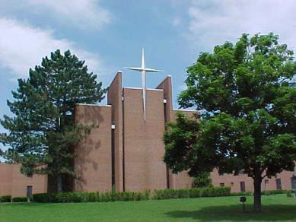
A well equipped facility, with breath-taking views of Canandaigua Lake

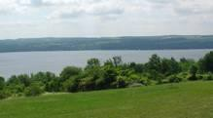
Beautiful, spacious grounds on a quiet hill

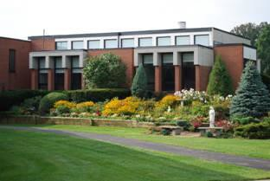
We know you will enjoy this lovely setting

