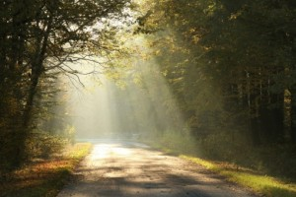
Upstate NY Synod Women of the ELCA 2019 Convention
“And God said . . . Walk a Faithful Journey”
Rest, relax, and recharge on beautiful Canandaigua Lake and enjoy a program of Bible study, spiritual reflection, fellowship, and workshops.
Where: Notre Dame Retreat House, 5151 Foster Road, Canandaigua, NY 14424
(585) 394-5700

When: October 4th – 6th
Registration: $65 for the weekend
Registration for Saturday only: $75 (includes meals)
Lodging: Cost for lodging includes all meals.
Double Room (2 beds) with full bath----$170 per person
Single Room (with sink and shared toilet) ---- $200 per person
Workshops: Presenter, Pastor Aileen Robbins - “Camino de Santiago”
*Pilgrimage to the shrine of the apostle St. James in Spain*

Any questions, contact Simone Harter at Lutheran Church of Our Saviour,
office@oursaviourrochester.org or (585) 247-7824
One World Goods will be available for your shopping pleasure.

